Trung Le

ECE 415 Computer Vision and IMG Analysis 1 -

670 451 575

Homework 2

1. **Thresholding**
2. 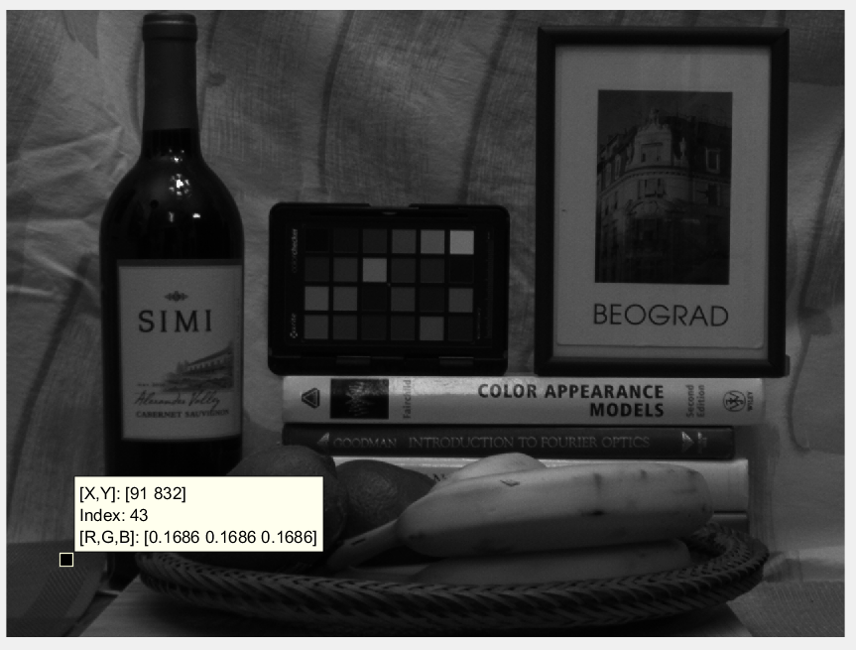**Display grayscale picture of image:**
3. 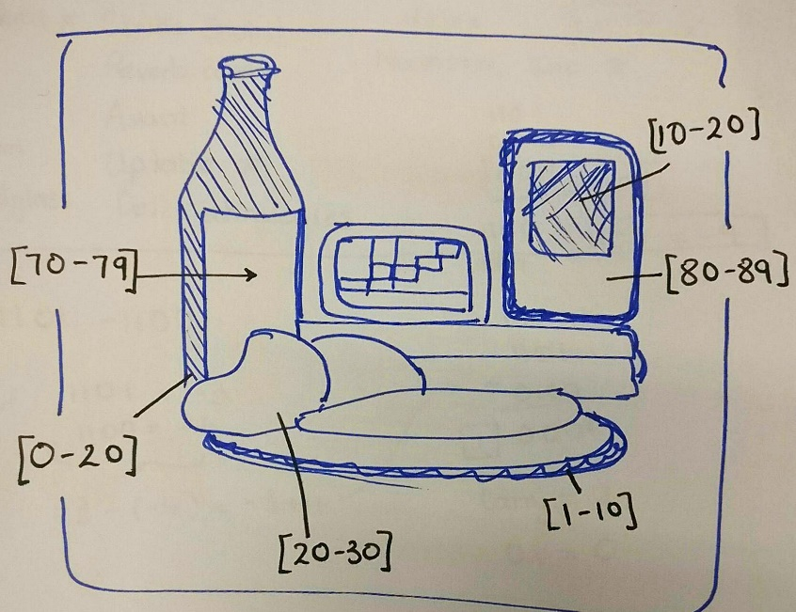**Apply thresholding**

A breakdown of the image is shown on the right. The goal of thresholding is to filter out the image regions of background and objects of interest. I analyzed the objects’ intensities and noted them down on the picture, using these values of intensity range will help improve thresholding.

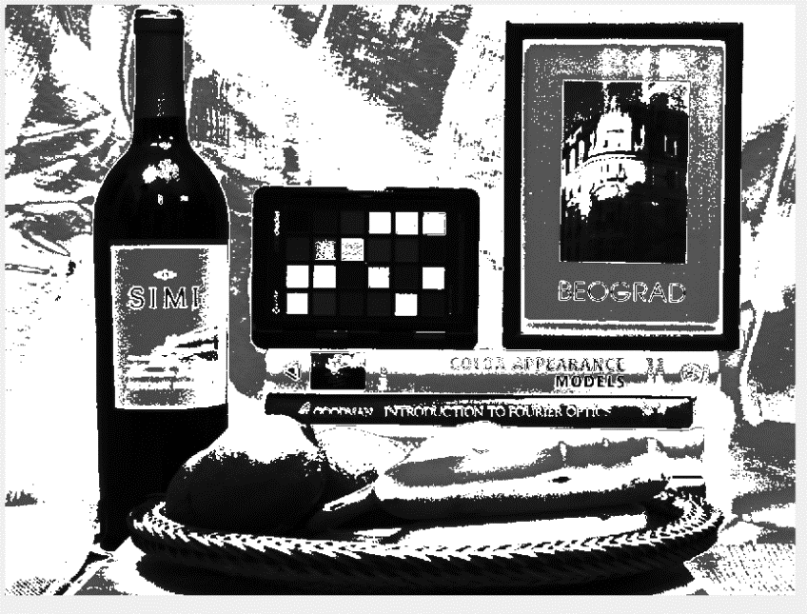METHOD 1:

Any intensity beside the range listed above will be changed to +255 instead of the original value.

Note: The objects stand out from the background much more due to 3 ranges of threshold applied to the image. However, it looks a bit “washed out” due to 255-intensity pixels dominate the picture.

**Threshold value**: [0-30] and [70-90] stay same intensity.

[30-70] and [90- 255] = 255 value intensity

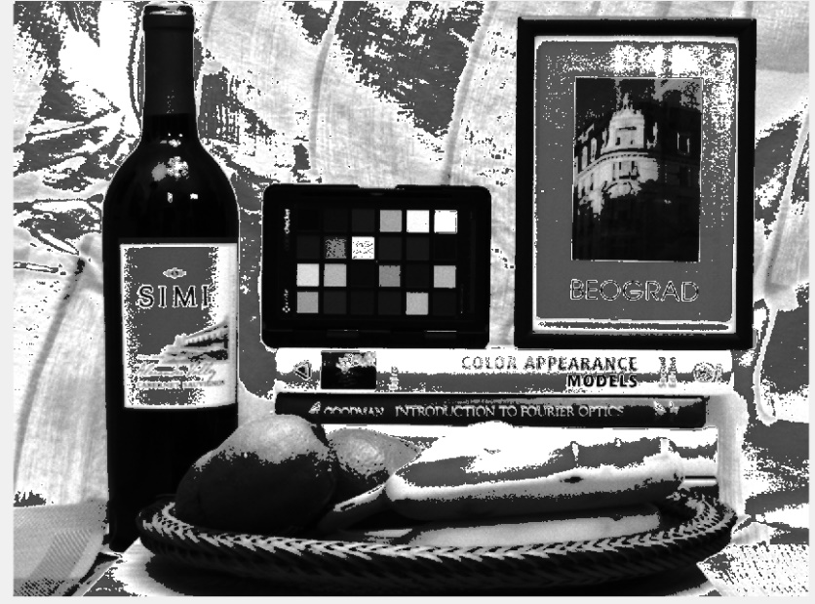

METHOD 2:

Any intensity beside the range listed above will be changed to *3 values of original intensity.

Note: This image now looks much better than method 1 due to the fact every pixel out of range will still keep some of its original value. It will enhance the white values to be whiter, and dark to be darker.

**Threshold value**: [0-30] and [70-90] stay same intensity.

[30-70] and [90- 255] = x*3 value intensity

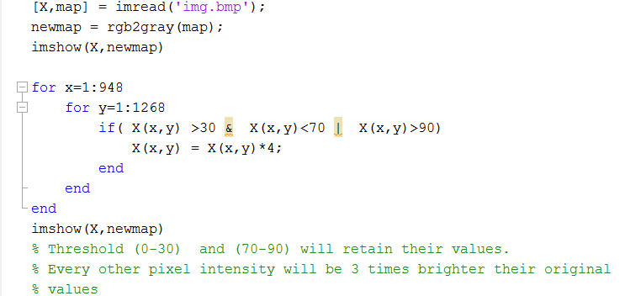CODE:

**PART 2: CONTRAST SKETCHING**

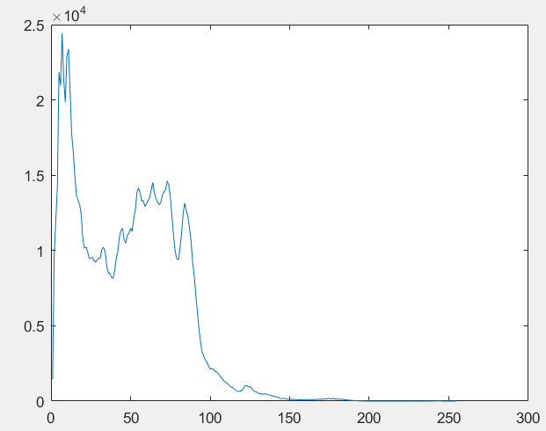**Step1**: Perform histogram on the image (without the usage of MATLAB functions)

Total pixels = 1,081,857 pixels.

5% of total pixels = 60,000 pixels.

I used for-loop starting i=1:255, count each pixels and increment the corresponding bins. Plot the (x,y) finally for the histogram shown here.

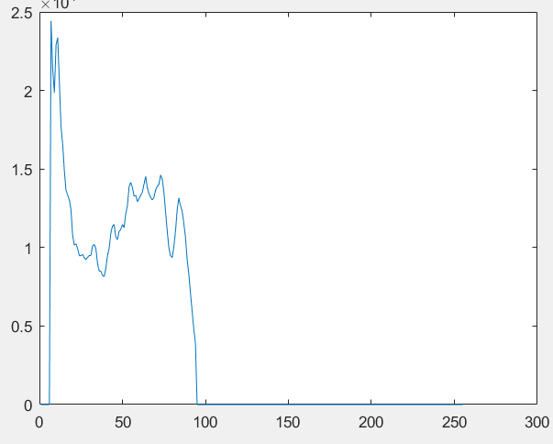**Step2**: Cut off 5% left and 5% right of histogram.

The cutoff is 60,000 pixels.

Starting from left i=1:255, accumulate the intensities until 60,000. That’s the left cut-off range. Repeat for right cut-off to find (c,d) respectively.

**Step3**: Apply the formula to contrast sketch the image.

With a=1, b= 255, c= 6, d= 95 ( c and d found in step 2)

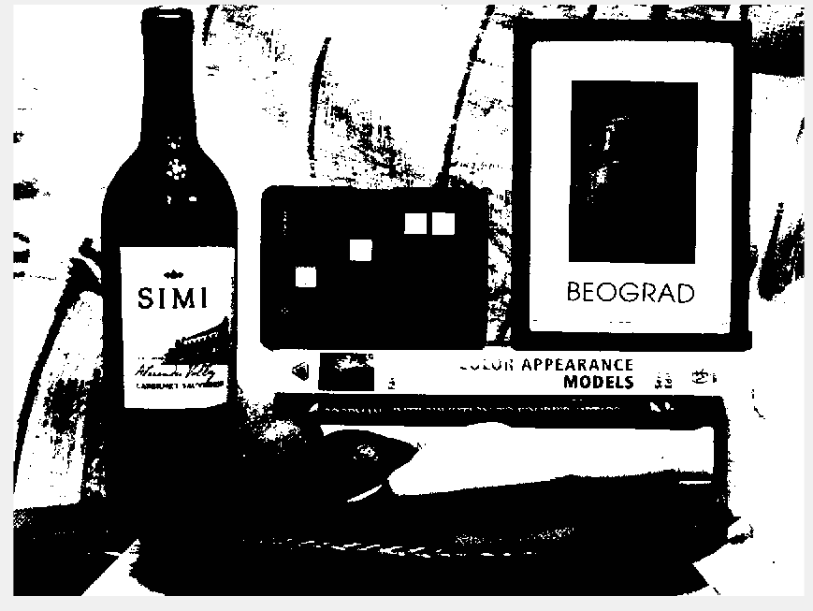 The range that was sketch was [6,95] -> [1,255] . The result is shown below:

Note: After contrast sketching, any pixels below and above the range [6,95] will be 0 and 255 respectively. Therefore it will completely make anything within range of 90% will be much easier to see. The result image is a little bit “harsh” since this is a linear operator, any pixel out of range will be flat =0 , and = 255.